Module 4: Option #1: Implementing SAS Hypothesis Testing
Taylor Weese
MIS500 – Introduction to Data Analytics
Colorado State University – Global Campus
Dwight Davis
May 12, 2019

Module 4: Option #1: Implementing SAS Hypothesis Testing
Module 4 Code
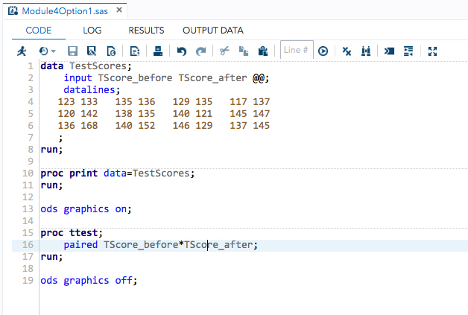

Module 4 Output
Table 1
Option #1

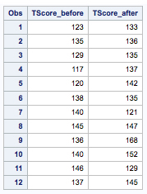
Note: This table is the output of the code for Option #1
Module 4 Results Tables
Table 2
Option #1
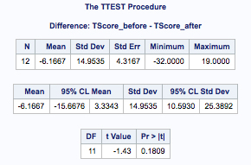
Note: This table is the TScore_before – Tscore_after Statistics, Confidence Limits and T-Tests
Module 4 Results Graphs
Graph 1
Option #1
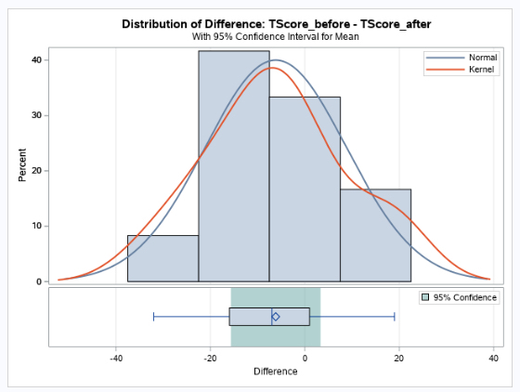
Note: This table is the TScore_before – Tscore_after Summary Panel

Graph 2
Option #1
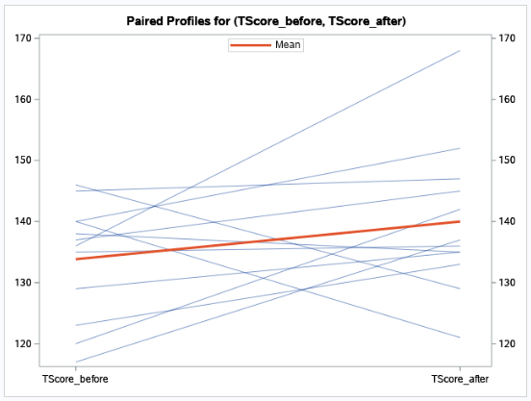
Note: This table is the TScore_before – Tscore_after Profile Plot

Graph 3
Option #1
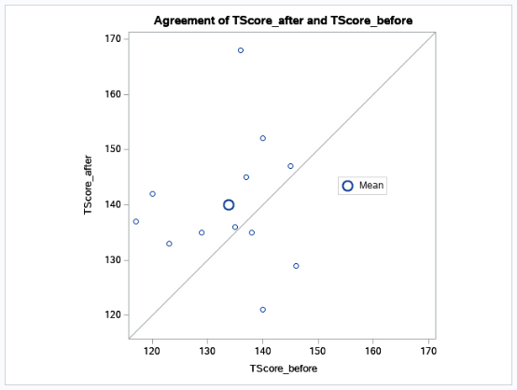
Note: This table is the TScore_before – Tscore_after Agreement Plot

Graph 4
Option #1
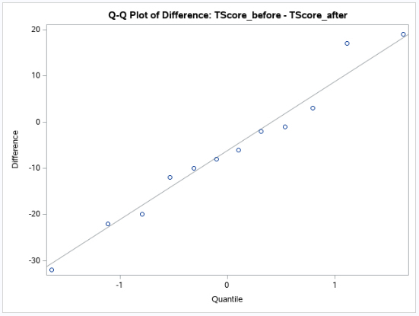
Note: This table is the TScore_before – Tscore_after Q-Q Plot

